**COURSEWORK SUBMISSION FORM**

|  |  |  |  |
| --- | --- | --- | --- |
| **STUDENT USE** | | **STAFF USE** | |
| Module Name | Web Applications Development | First Marker’s  (acts as signature) |  |
| Module Code | **5COSC017C-n** | Second Marker’s  (acts as signature) |  |
| Lecturer Name | **Subair Ali Liayakath Ali Khan** | Agreed Mark |  |
| UoW Student IDs |  | **For Registrar’s office use only (hard copy submission)** | |
| WIUT Student IDs | 00010023 |
| Deadline Date | 06/04/2022 11:59:59 PM |
| Assignment Type | ☐ Group ☑ Individual |
| Word Count | 2260 |

**SUBMISSION INSTRUCTIONS**

**COURSEWORKS *must* be submitted in *both* HARD COPY (to the Registrar’s Office) *and* ELECTRONIC unless instructed otherwise.**

For hardcopy submission instructions refer to: <http://intranet.wiut.uz/Shared%20Documents/Forms/AllItems.aspx> - Coursework hard copy submission instructions.doc

For online submission instructions refer to: <http://intranet.wiut.uz/Shared%20Documents/Forms/AllItems.aspx> - Coursework online submission instructions.doc

|  |
| --- |
| **MARKERS FEEDBACK (Continued on the next page)** |
|  |

Table of Contents

Brief description and e-commerce platform 2

Company Analysis 3

E-Commerce and revenue models  3

CRM 4

Advertising strategy 4

Target audience and consumer behavior 5

Industry and Competitor’s analysis 5

Recommendations 6

Issues 6

Solutions 6

Future vision 7

Bibliography and appendix 8

Reference list 10

* **Brief description and e-commerce platform**

The primary analysis of this report will be directed at one of the famous pizzeria companies in Uzbekistan: Chopar Pizza. Prior to proceeding to analysis of its e-commerce environment and business-related information, some words should be written about the history of the company. Starting from the year 2015, Chopar Pizza consistently and clearly proves that conventional Eastern products are able to be converted into a pizza in the hands of experts, which constantly wins the hearts of genuine gourmets. It is interesting to note that in translation from Uzbek, the brand name Chopar means “Chaser”. The company has been confirming its brand name already for 7 years, not only because of fast deliveries, but also due to playing the role of an authentic chaser, which heralds fresh news and tastes within the spectrum of Eastern values, European gastronomic traditions and state-of-the-art technology. The brand Chopar Pizza is considered to be a part of a group within “Havoqand people” companies. It successfully provides its services in the market of Uzbekistan and CIS, opening new branches. In 2021, the business has also entered the market in Kazakhstan, having presented its own formatted vision of pizzeria to new consumers. When it comes to current environment of e-commerce platform, it appears to be quite advanced from technological point of view. Chopar Pizza utilizes SaaS platform, which means that its services are active in a software environment. These days, the use of SaaS platforms is becoming more and more prevalent when it comes to developing businesses, as it provides them with many advantages. According to Bin Wi and his colleagues (2011), SaaS platform benefits companies in terms of investment decrease, performance growth, saving time, wide accessibility, simplified cooperation and so on. After finding out the company’s general information, we can predict that the growing success will not vanish both in the long-term and short-term future.

* **E-Commerce and revenue models**

Having revealed the main e-commerce platform of Chopar Pizza, it is important to analyze how its system works. To start with, the company has quite an interesting online ordering environment. Its ordering system is divided into two online operations. The first one is selling services and products through website, and the second one is via social network by activating a bot. Customers, first of all, can easily enter the website link and proceed with choosing different products in a beautifully designed menu and add them to the cart. The same is true for ordering based on social network, where a bot needs to be activated. However, it should be noted that ordering via bot seems much easier especially when it comes saving time and details. The reason for this could be because users are presented with many detailed options and question, once the bot is activated. By contrast, most of the detailed information can be acquired when customers order through the website, where they have to call to the representative responsible for taking orders. Even though, there is great difference in online ordering systems, we should not forget that there are two of them, which means e-commerce environment is actively focused by the company. If we consider e-commerce revenue models of Chopar Pizza, they seem to be clearly present. Ojala (2013) in his article writes that SaaS platform could have 5 e-commerce revenue models, which are sales, subscription, advertising, transaction and affiliate revenue models. It appears that the company covers all those revenue aspects, except for subscription and affiliate-based models. The business seems to have no intention of making profit by adding subscription fee or creating a specific referral where users would get special bonuses, with the help of which, it would be possible to make purchases. Other revenue models, however, are carefully considered by the company. For example, given the sales revenue model, the business simple sells its services and products, which generate income on a regular basis. If we consider transaction-based revenue model, Chopar Pizza appears to be receiving some fee when a customer utilizes mobile applications to pay for a certain service. The last model included in the business is advertising. The company puts efforts to advertise only its own products via website and social network by sharing posts with attractive orders and discounts.

* **CRM**

Analyzing customer relationship management of Chopar Pizza, we can say with certainty say that it is actively performed for the reasons which will be discussed below. Before proceeding with analysis, the arising question is, why do businesses need CRM? According to Al-Weshah (2019), CRM is not simply a system created for capturing information regarding customers, it also serves as an information provider on how to satisfy the desires of current customers and helps locate new customers. As it was analyzed earlier, the company has got 2 sources of interacting online with its consumers, one of them is achieved with the help of social network, while the second is achieved with the ordering system on the website. Both of them appear to be customer-friendly, which means all functions and options available to order a service answer potential issues which could arise from a customer. For instance, after finishing a certain order, customer gets informed about the details of his driver and his approximate time of arrival. When a driver arrives at the destination, the consumer once again gets informed by message. Apart from that, customers can leave their comments inside the activated bot which is taken account by responsible person. All of these indicate that the business strongly focuses on retaining relationship with its customers

* **Advertising strategy**

When it comes to advertising strategy of Chopar Pizza, it is considered in an extraordinary way. Instead of publishing adverts from third-party companies, by receiving fee for that, the business focuses on attracting customers by publishing company-related adverts. To illustrate, as it has already been written earlier, the company tends to publish special offers as well as discounts, which are sent to the online bot. The bot seems not only to have ordering system installed, but it also acts as a real advertiser. From the viewpoint of a user, it can be considered as a professional advertising, since customers get notified only about pizza-related services. Otherwise, if the bot starts publishing adverts which belong to other companies, users can lose their interest and simply mute the bot. This could result in a great decrease in the number of orders made online. Others, however, could disagree. Bonoma (2001) in his article writes that although it is quite simple to come up with a well-considered advertising strategy, it is still difficult to implement them so that they work under company. Therefore, it is not a mistake to presume that Chopar Pizza has considered different aspects of advertising strategies and chose the most optimal one, which is publishing only business-dedicated adverts.

* **Target audience and consumer behavior**

Given the company’s services and products, we can clearly state that the target audience is oriented towards all people of different ages, since all people need nutrition, do not they? As for consumer behavior, there a number of options and functions provided for users when it comes to ordering foof online. For example, once a user activates the bot, they can choose whether the service will be delivered or there is need for picking it up. They are, then, asked by the bot to turn on GPS to get their locations and after some retrieval of geolocation, they are presented with the address. A user, thereafter, can pick the desire pizza and clarify its size and other properties by clicking on their devices. Once the products are chosen, users can add them to the cart and leave some comments to the driver about their exact location. In a few seconds, the user receives the check with the order number and its estimated time of arrival. In case a user orders via website, he/she can only add pizzas with its properties to the cart, and then call the extension number. This could be a problem, as it appears the website cannot act as detailed as the social network does, which will be thoroughly analyzed in the recommendation part

* **Industry and competitor’s analysis**

Considering the company’s ordering activity with two online platforms, it is predictable that the industry becomes more and more successful. However, the arising question is, what about its potential competitors? In recent years, a new company has entered the local market, the brand of which is called Dodo Pizza. It appears that its name has already been popular in other countries because people seem to have heard of it, while Chopar Pizza was not initially as famous as its competitor. In terms of sales, the services provided by Dodo Pizza appear to be slightly cheaper than those available in Chopar Pizza. Yet, when it comes to online activity, the company definitely has a competitive advantage due the presence of social network ordering. It was revealed that even though Dodo Pizza sells its products both offline and online through website, it does not have a social network ordering platform. Instead, it has a channel with a certain number of subscribers where it publishes service-related adverts with special offers. In all other aspects, there is not much difference. Both online platforms on the website are quite similar in the way ordering services are processed. In terms of web design, there is not a big gap either; the construction of both websites are customer-oriented and no information except the business-related products can be located.

* **Issues**

One of the main problems of company’s e-commerce platform is incompletion of online ordering system on the website. What I mean is that customers always have to dial extension number and reach the person responsible for generating an order in the database once they finish collecting the online cart. This could entail some difficulties for the business in terms of communication as well as CRM. While talking on the phone, some details may not be understood and it can be time-consuming when it comes to clarifying information from a consumer. For example, there could be issues with understanding the exact location of a customer when the directions are provided via phone call. Another identified issue is related to online marketing techniques on the website. In other words, from the perspective of a customer, the costs of services may seem quite expensive after opening the website. To illustrate, the first pizza which is presented on the website is “Bayram” which costs 86,000 sums. At first glance, a customer may lose the desire to decide whether it is worth buying products online or not, and even change the preference of choosing Chopar Pizza. Although these problems may appear miniature, addressing them could bring huge benefits to the company in terms of financial situation and customer retention.

* **Solutions**

To overcome the first problem which is related to online ordering system on the website, more online operations should be added. Apart from adding products on the cart, it would be wise to consider implementing online functions and techniques that are available on social network i.e. bot. If there are more options and buttons presented to the customer, most of their inquiries could be addressed with a relative ease, and there would be no need for dialing the responsible person for clarifying details. The website, for example, could have a function for locating the address of a person ordering services, and it also could retrieve some additional information provided by that person. After retrieving all the data, a function responsible for adding the information into a database could be created. Once all these requirements are fulfilled, it can be said with certainty that there would be no need for phone calls. As far as the second issue is concerned, which is regarding online marketing, one of the advertising strategies could be implemented. Since the price of services may appear expensive at first glance, the company could tag some of its products as “discounted”. What I mean is that one of the ways to attract a potential customer online is create more expensive product price, cross it out and add a discount. For instance, if one pizza under the name “Bayram” costs 86,000 soums, the company can come up with a bigger number, be it 96,000, and cross it out by stating that there is a 12% discount. Although this marketing technique may appear irrelevant to the topic, it still makes sense when it comes to solving issues with retaining customers and generating more income.

* **Future vision of e-commerce**

In the future, be it short-term or long-term, it can be anticipated that Chopar Pizza will remain successful in case they continue putting much effort to online operations, for technological advances and the Internet are only becoming prevalent over the past few years. In terms of e-commerce platform, it can be stated with no doubt that the company will continue improving its online environment owing to one specific reason. It appears that the website is built with the latest and strongest platform. Chopar Pizza utilizes strong web and JS framework, which are React and Next.js respectively. User interface is constructed with a clean framework, Tailwind CSS. Issue trackers as well as reverse proxies are also present on the website, which are Sentry and Nginx in turn. The website has also been constructed with the help of two strong JS libraries, Lodash and Core.js. All these features only indicate that the business pays huge attention to online development, which is a great step to becoming renowned among competitors and customers.

* **Bibliography and Appendix**

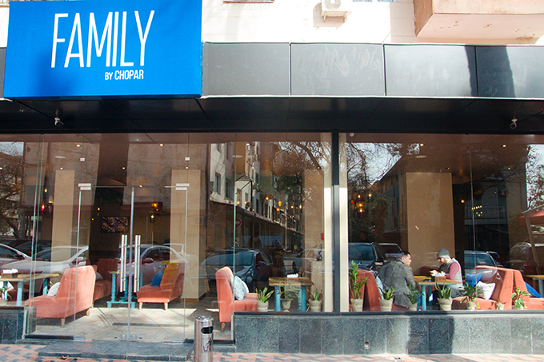

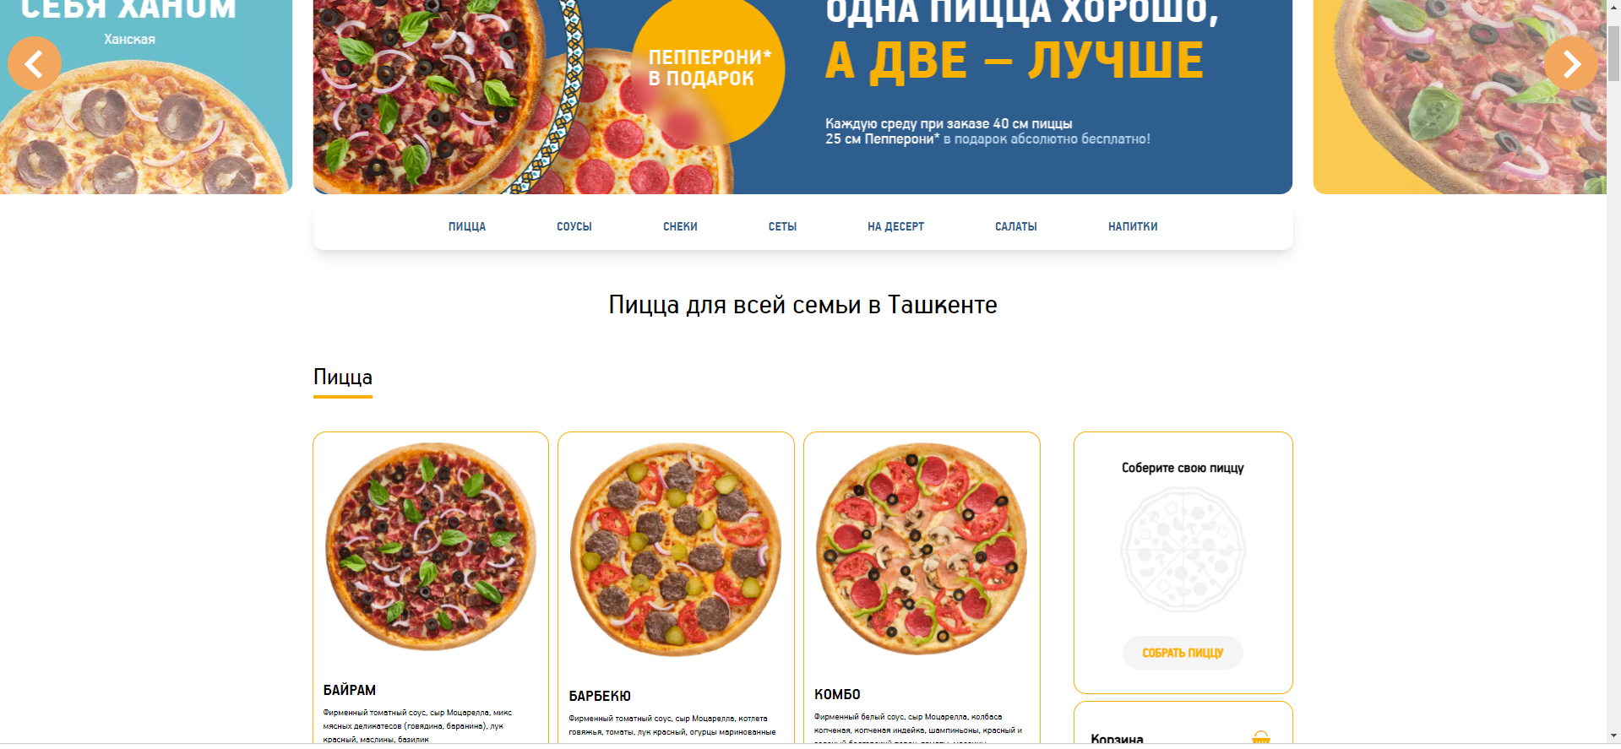

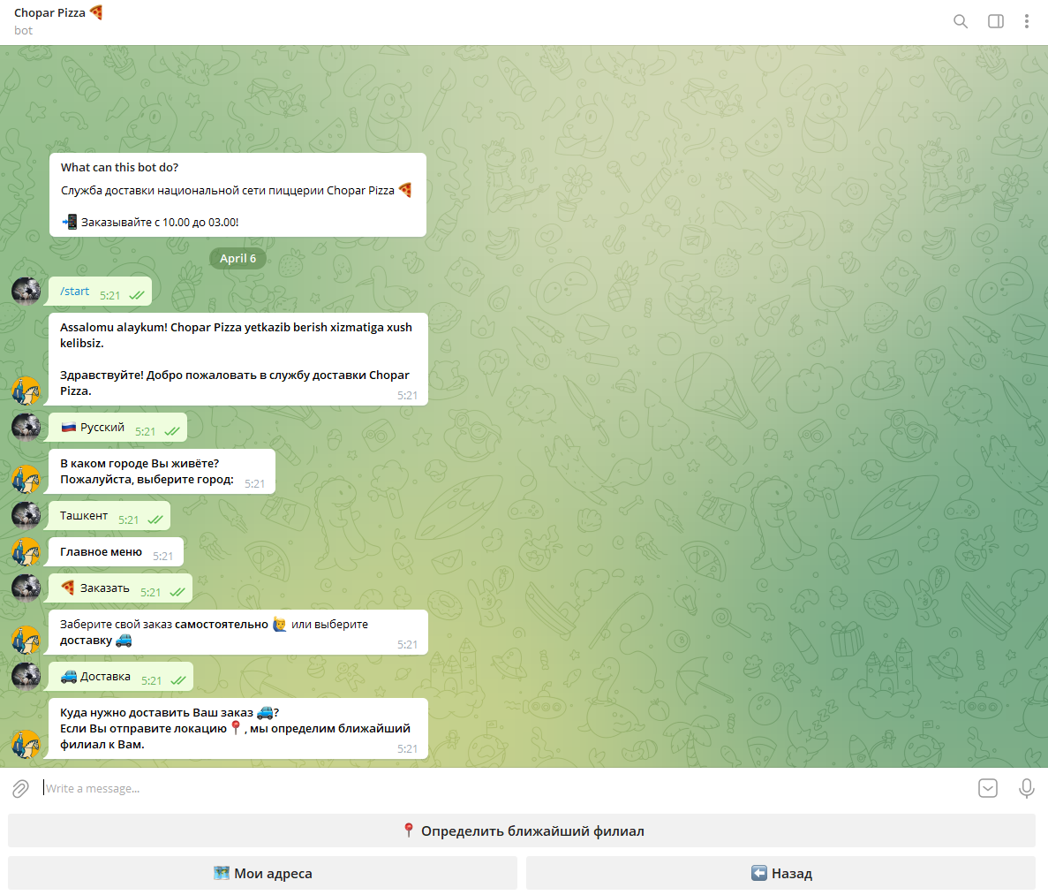

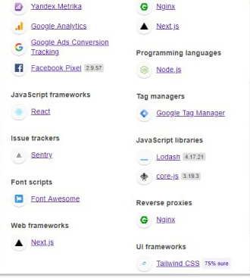

**Reference list**

Al-Weshah, G. (2019). The current status of customer relationship management: experience of small businesses in the Jordanian food industry. *Int. J. Electronic Customer Relationship Management.* 12(1). Available from <https://www.inderscienceonline.com/doi/pdf/10.1504/IJECRM.2019.098975> [Accessed 3 April 2022]

Bonoma, T. (2003). Making Your Marketing Strategy Work. *Harvard Business Review*. Available from <https://hbr.org/1984/03/making-your-marketing-strategy-work> [Accessed 2 April 2022]

Chopar Pizza. Avaialble from <https://choparpizza.uz/tashkent> [Accessed 31 March 2022]

Dodo Pizza. Available from <https://dodopizza.uz/tashkent> [Accessed 2 April 2022]

Ojala, A. (2013). Software-as-a-Service Revenue Models. *Institute of Electrical and Electronics Engineers*. 15(3). Available from <https://ieeexplore.ieee.org/abstract/document/6243129> [Accessed 3 April 2022]

Wu, B. et al. (2011). Reference Models for SaaS Oriented Business Workflow Management Systems. Available from <https://ieeexplore.ieee.org/abstract/document/6009267> [Accessed 31 March 2022]